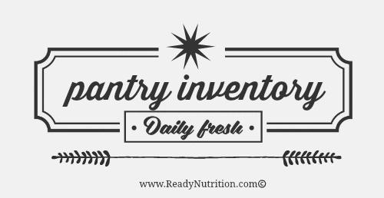

**CANNED GOODS**

item amount use by

|  |  |  |
| --- | --- | --- |
|  |  |  |
|  |  |  |
|  |  |  |
|  |  |  |
|  |  |  |
|  |  |  |
|  |  |  |
|  |  |  |
|  |  |  |
|  |  |  |

**BAKING/SPICES**

item amount use by

|  |  |  |
| --- | --- | --- |
|  |  |  |
|  |  |  |
|  |  |  |
|  |  |  |
|  |  |  |
|  |  |  |
|  |  |  |
|  |  |  |
|  |  |  |
|  |  |  |

**BEANS/GRAINS/PASTA**

item amount use by

|  |  |  |
| --- | --- | --- |
|  |  |  |
|  |  |  |
|  |  |  |
|  |  |  |
|  |  |  |
|  |  |  |
|  |  |  |
|  |  |  |
|  |  |  |
|  |  |  |

**cONDIMENTS**

item amount use by

|  |  |  |
| --- | --- | --- |
|  |  |  |
|  |  |  |
|  |  |  |
|  |  |  |
|  |  |  |
|  |  |  |
|  |  |  |
|  |  |  |
|  |  |  |
|  |  |  |